Week 6
1.ReactJS HOL
Define SPA (Single-Page Application) and its Benefits
- SPA is a web application that loads a single HTML page and dynamically updates content without reloading the page.
- Uses JavaScript to fetch data and update the UI.
Benefits of SPA:
- Faster navigation between pages.
- Reduces server load.
- Smoother user experience (like a mobile app).
- Efficient data handling using APIs (e.g., REST, GraphQL).

Define React and Identify Its Working
- React is a JavaScript library used for building user interfaces, especially for single-page applications.
- Developed by Facebook.
- Component-based architecture.
How React Works:
- Uses JSX to write HTML in JavaScript.
- Breaks UI into reusable components.
- Uses Virtual DOM for efficient UI updates.
- React compares changes and updates only the changed parts in the DOM.

Differences Between SPA and MPA (Multi-Page Application)
Feature | SPA | MPA
Page Load | Single load, dynamic content | Loads new page every time
Speed | Faster navigation | Slower due to full reloads
Development | More dependent on JS | More server-side rendering
User Experience | Smooth, app-like | Traditional, less dynamic
SEO | Harder (can be managed) | Easier to handle SEO

Pros & Cons of Single-Page Application (SPA)
Pros:
- Fast and responsive.
- Reduces server requests.
- Better user experience.
- Reusable front-end components.
Cons:
- Poor SEO (needs extra setup).
- Initial load time can be high.
- JavaScript must be enabled in the browser.
- Complex to secure and manage routes.

Explain About React
- Open-source JS library for UI development.
- Handles view layer in web and mobile apps.
- Works with virtual DOM.
- Supports component-based architecture.
- Enables efficient rendering using React hooks and state.

Define Virtual DOM
- Virtual DOM is a lightweight copy of the actual DOM.
- React uses it to track changes and update only the parts of the real DOM that changed.
- Improves performance by reducing DOM manipulation.
- Uses diffing algorithm to compare changes.

Features of React
- Component-Based: Break UI into reusable pieces.
- Virtual DOM: Fast and efficient updates.
- JSX: JavaScript + HTML-like syntax.
- One-Way Data Binding: Data flows in one direction (top to bottom).
- Hooks: Add state and side-effects in functional components.
- Performance: Faster UI with minimal DOM changes.
- Strong Community: Backed by Facebook and large developer support.
- React Native: Build mobile apps using React.
Steps:
App.js :-
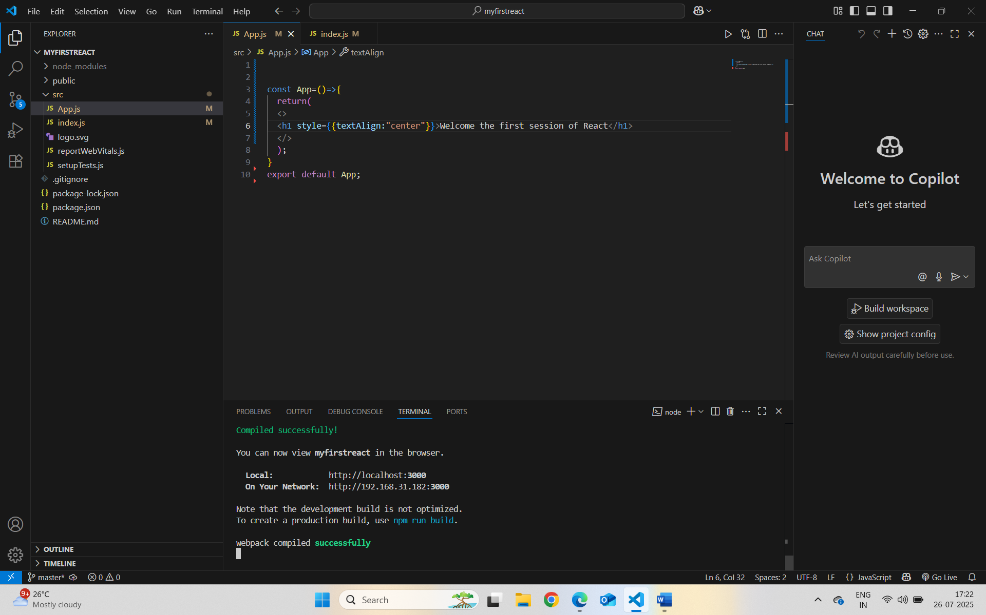
npm start in terminal:-
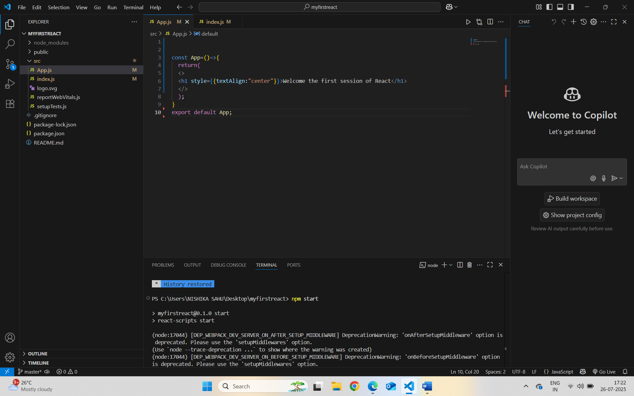
Localhost:3000 :-



